DLD Lab 04*[In-Lab Tasks]*

**[Muhammad Ibrahim]-[24K-0649]**

# **Task 01:**

## Minimum SOP:

$$AB+BC+\overline{A}\overline{B}\overline{C}$$

## Circuit Diagram:

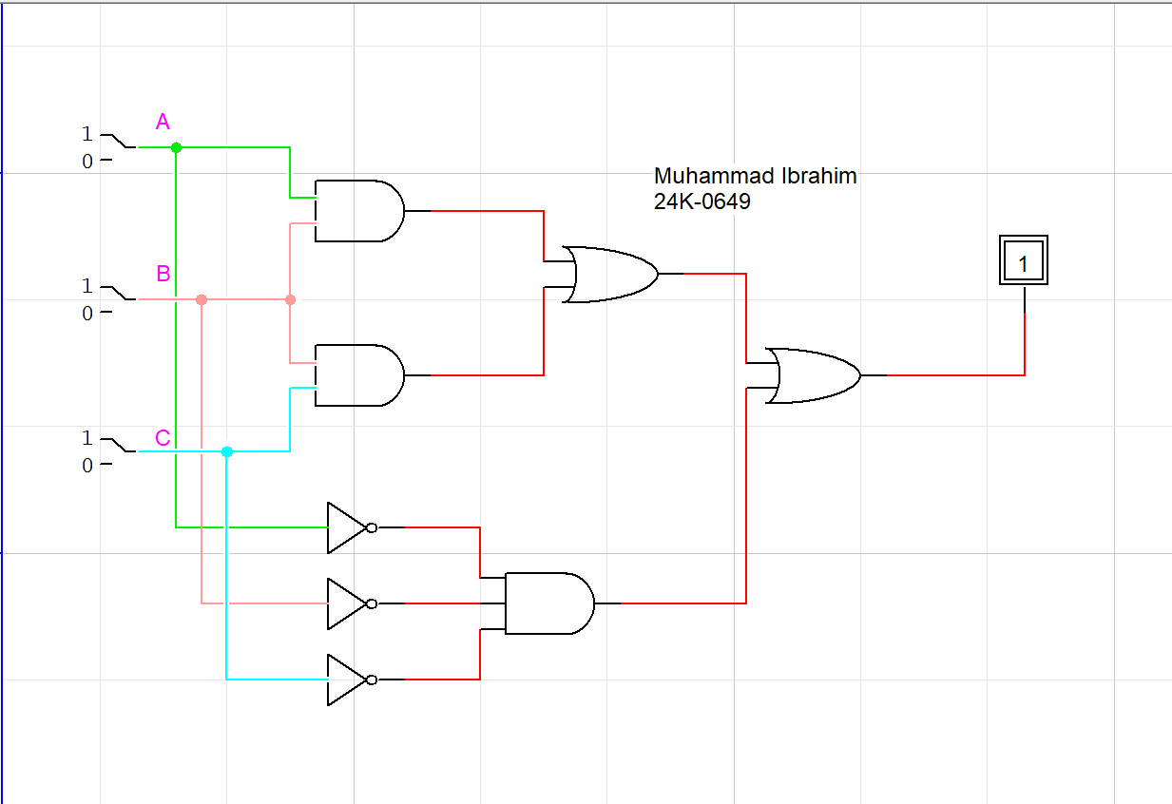

## Truth Table:

|  |  |  |  |
| --- | --- | --- | --- |
| **A** | **B** | **C** | **D** |
| 0 | 0 | 0 | 1 |
| 0 | 0 | 1 | 0 |
| 0 | 1 | 0 | 0 |
| 0 | 1 | 1 | 1 |
| 1 | 0 | 0 | 0 |
| 1 | 0 | 1 | 0 |
| 1 | 1 | 0 | 1 |
| 1 | 1 | 1 | 1 |

## Actual Expression:

$$\overline{A}\overline{B}\overline{C}+\overline{A}BC+AB\overline{C}+ABC$$

## Circuit Diagram:

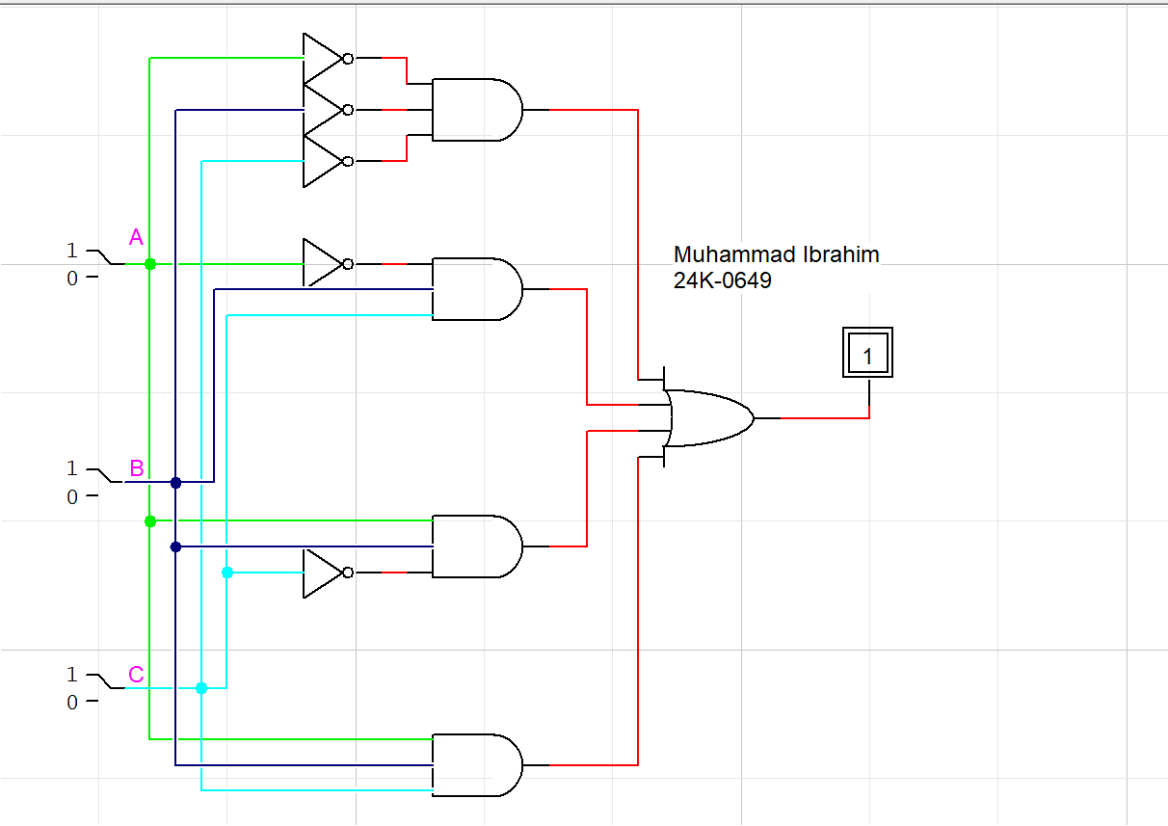

## Truth Table:

|  |  |  |  |
| --- | --- | --- | --- |
| **A** | **B** | **C** | **D** |
| 0 | 0 | 0 | 1 |
| 0 | 0 | 1 | 0 |
| 0 | 1 | 0 | 0 |
| 0 | 1 | 1 | 1 |
| 1 | 0 | 0 | 0 |
| 1 | 0 | 1 | 0 |
| 1 | 1 | 0 | 1 |
| 1 | 1 | 1 | 1 |

# **Task 02:**

## Minimum SOP:

$$\overline{A}\overline{C}+AC+\overline{B}$$

## Circuit Diagram:

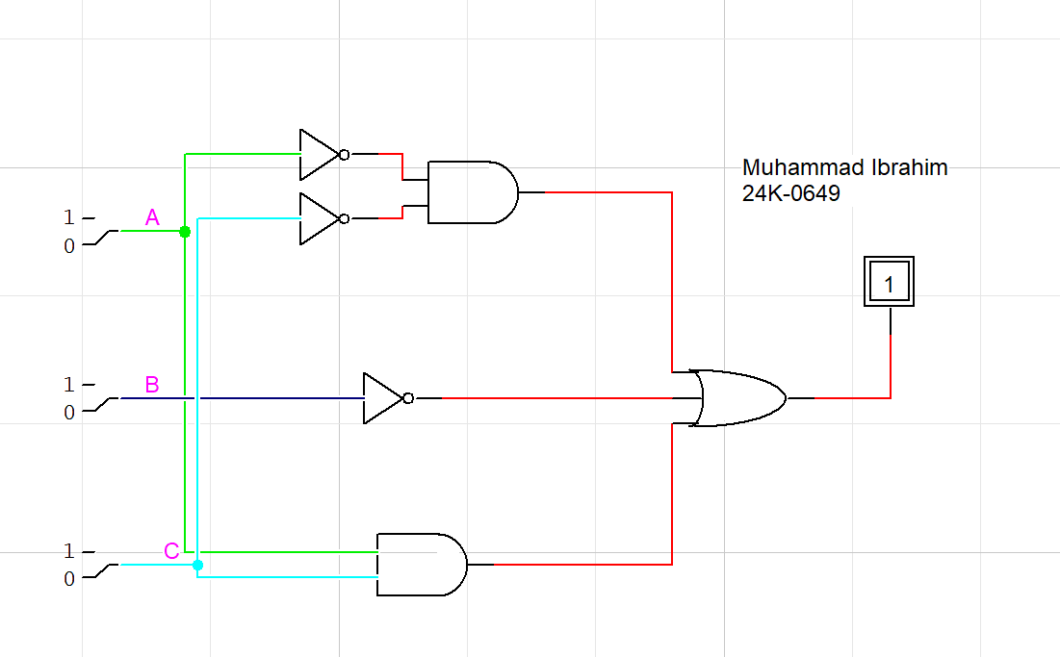

## Truth Table:

|  |  |  |  |
| --- | --- | --- | --- |
| **A** | **B** | **C** | **D** |
| 0 | 0 | 0 | 1 |
| 0 | 0 | 1 | 1 |
| 0 | 1 | 0 | 1 |
| 0 | 1 | 1 | 0 |
| 1 | 0 | 0 | 1 |
| 1 | 0 | 1 | 1 |
| 1 | 1 | 0 | 0 |
| 1 | 1 | 1 | 1 |

## Actual Expression:

$$\overline{A}\overline{B}\overline{C}+\overline{A}\overline{B}C+\overline{A}B\overline{C}+ABC+A\overline{B}\overline{C}+A\overline{B}C$$

## Circuit Diagram:

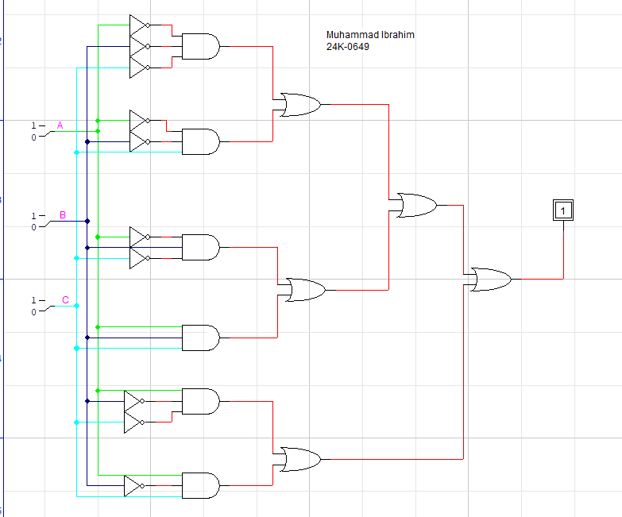

## Truth Table:

|  |  |  |  |
| --- | --- | --- | --- |
| **A** | **B** | **C** | **D** |
| 0 | 0 | 0 | 1 |
| 0 | 0 | 1 | 1 |
| 0 | 1 | 0 | 1 |
| 0 | 1 | 1 | 0 |
| 1 | 0 | 0 | 1 |
| 1 | 0 | 1 | 1 |
| 1 | 1 | 0 | 0 |
| 1 | 1 | 1 | 1 |